**Project Documentation**

**Name: Dan Beck**

**Assignment: Project 1**

**Date: September 1, 2020**

**Problem Statement**: The writing a program that converts prefix expressions to postfix and postfix expressions to prefix.

**Analysis:** Expressions used:

Posfix to prefix test – 2 2 12 9*2-+/

Prefix to postfix test - * + * 2 / 2 -+ 12 9 2

**Design:**

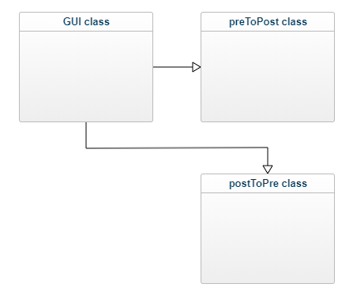

**Code:**

package BeckProject1;

import java.awt.event.ActionEvent;

import java.awt.event.ActionListener;

import javax.swing.JButton;

import javax.swing.JFrame;

import javax.swing.JLabel;

import javax.swing.JOptionPane;

import javax.swing.JTextField;

import java.awt.Rectangle;

import java.awt.Font;

/* File: Project 1 - GUI

* Author: Dan Beck

* Date: August 29, 2020

* Purpose: Class that generates the GUI and passes parameters to

* other classes.

*/

public class GUI

{

public GUI()

{

//***************Frame******************

//Generates the JFrame

JFrame frame = new JFrame();

frame.setBounds(new Rectangle(600, 400, 450, 175));

frame.setTitle("Expression Converter");

frame.setDefaultCloseOperation(JFrame.EXIT_ON_CLOSE);

frame.getContentPane().setLayout(null);

//***************Text Fields******************

//Generates the text field to see the results

JTextField resultText = new JTextField();

resultText.setEditable(false);

resultText.setColumns(10);

resultText.setBounds(125, 95, 285, 20);

frame.getContentPane().add(resultText);

frame.setVisible(true);

//Generates the text field to enter expression

JTextField expressionText = new JTextField();

expressionText.setBounds(125, 10, 285, 20);

frame.getContentPane().add(expressionText);

expressionText.setColumns(10);

//***************Buttons******************

//Generates the prefix to postfix button

JButton prefixToPostfixButton = new JButton("Prefix to Postfix");

prefixToPostfixButton.setFont(new Font("Tahoma", Font.BOLD, 11));

prefixToPostfixButton.setBounds(70, 45, 130, 40);

frame.getContentPane().add(prefixToPostfixButton);

prefixToPostfixButton.addActionListener(new ActionListener()

{

public void actionPerformed(ActionEvent e)

{

try

{

String expression = expressionText.getText();

preToPost preTp = new preToPost();

resultText.setText(preTp.preToPost(expression));

}//end try

catch(Exception e1)

{

JOptionPane.showMessageDialog(null, "Please enter a valid Prefix expression!");

}//end catch

}//end Action Performed

});//addActionListener

//Generates the postfix to prefix button

JButton postfixToPrefixButton = new JButton("Postfix to Prefix");

postfixToPrefixButton.setFont(new Font("Tahoma", Font.BOLD, 11));

postfixToPrefixButton.setBounds(230, 45, 130, 40);

frame.getContentPane().add(postfixToPrefixButton);

postfixToPrefixButton.addActionListener(new ActionListener()

{

public void actionPerformed(ActionEvent e)

{

try

{

String expression = expressionText.getText();

postToPre postTp = new postToPre();

resultText.setText(postTp.postToPre(expression));

}//end try

catch(Exception e2)

{

JOptionPane.showMessageDialog(null, "Please enter a valid Postfix expression!");

}//end catch

}//end Action Performed

});//addActionListener

//***************Labels******************

//Generates the results label

JLabel resultLabel = new JLabel("Result:");

resultLabel.setFont(new Font("Tahoma", Font.BOLD, 12));

resultLabel.setBounds(70, 95, 55, 20);

frame.getContentPane().add(resultLabel);

//Generates the Enter Expression label

JLabel enterExpressionLabel = new JLabel("Enter Expression:");

enterExpressionLabel.setFont(new Font("Tahoma", Font.BOLD, 12));

enterExpressionLabel.setBounds(10, 10, 120, 20);

frame.getContentPane().add(enterExpressionLabel);

}

public static void main(String[] args)

{

// TODO Auto-generated method stub

new GUI();

}//End Main

}//End GUI class

package BeckProject1;

import java.util.Stack;

import java.util.StringTokenizer;

/* File: Project 1

* Author: Dan Beck

* Date: August 29, 2020

* Purpose: Class that receives Prefix expression and converts it

* to a Postfix expression.

*/

class preToPost

{

//function that checks if character is an operator

static boolean isOperator(String op)

{

switch (op)

{

case "+":

case "-":

case "/":

case "*":

return true;

}//end switch (check)

return false;

}//end static boolean isOperator(String check)

//Converts Prefix to Postfix

String preToPost(String convert)

{

//New string to be generated

StringBuffer newString = new StringBuffer();

//Sets the first character of the new string

newString.append(convert.charAt(0));

for (int i = 1, n = convert.length(); i < n; i++)

{

//Checks if character is a space

if(Character.*isSpaceChar*(convert.charAt(i)))

{

newString.append(convert.charAt(i));

}

//checks if character is a digit with an operator before it

else if(*isOperator*(String.*valueOf*(convert.charAt(i-1))) == true &&

Character.*isDigit*(convert.charAt(i)))

{

newString.append(" " + convert.charAt(i));

}

//checks if character is a operator with a digit before it

else if(Character.*isDigit*(convert.charAt(i-1)) &&

*isOperator*(String.*valueOf*(convert.charAt(i))) == true)

{

newString.append(" " + convert.charAt(i));

}

//checks if character is an operator with an operator before it

else if(*isOperator*(String.*valueOf*(convert.charAt(i))) == true &&

*isOperator*(String.*valueOf*(convert.charAt(i-1))) == true)

{

newString.append(" " + convert.charAt(i));

}

//checks if character is a digit

else if (Character.*isDigit*(convert.charAt(i)))

{

newString.append(convert.charAt(i));

}

//Passes the character through if none others are met

else

{

newString.append(convert.charAt(i));

}

}//end for (int i = 0, n = convert.length(); i < n; i++)

//tokenize the string containing the prefix expression

StringTokenizer st = new StringTokenizer(convert);

//two stacks to perform the conversions

Stack<String> rs = new Stack<String>();

Stack<String> s = new Stack<String>();

//read the tokens

while (st.hasMoreTokens() == true)

{

rs.push(st.nextToken());

}//end while (st.hasMoreTokens() == true)

while (rs.empty() == false)

{

String check = rs.pop();

// check if symbol is operator

if (*isOperator*(check) == true)

{

// pop two operands from stack

String n1 = s.peek(); s.pop();

String n2 = s.peek(); s.pop();

// concats the operands and operator

String makeNew = n1 + n2 + check;

// Push makeNew back to stack

s.push(makeNew + " ");

}//end if (isOperator(check) == true)

// if symbol is an operand

else

{

//push the operand to the stack

s.push(check + " ");

}//end else

}//end while (rs.empty() == false)

//shows the stack containing only the Postfix expression

return s.peek();

}//end String preToPost(String pre_exp)

}// end class preToPost

package BeckProject1;

import java.util.Stack;

import java.util.StringTokenizer;

/* File: Project 1 - postToPre

* Author: Dan Beck

* Date: August 29, 2020

* Purpose: Class that receives Postfix expression and converts it

* to a Prefix expression.

*/

public class postToPre

{

//function that checks if character is an operator

static boolean isOperator(String op)

{

switch (op)

{

case "+":

case "-":

case "/":

case "*":

return true;

}//end switch (check)

return false;

}//end static boolean isOperator(String check)

//Converts Postfix to Prefix

String postToPre(String convert)

{

//New string to be generated

StringBuffer newString = new StringBuffer();

//Sets the first character of the new string

newString.append(convert.charAt(0));

for (int i = 1, n = convert.length(); i < n; i++)

{

//Checks if character is a space

if(Character.isSpaceChar(convert.charAt(i)))

{

newString.append(convert.charAt(i));

}

//checks if character is a digit with an operator before it

else if(isOperator(String.valueOf(convert.charAt(i-1))) == true &&

Character.isDigit(convert.charAt(i)))

{

newString.append(" " + convert.charAt(i));

}

//checks if character is a operator with a digit before it

else if(Character.isDigit(convert.charAt(i-1)) &&

isOperator(String.valueOf(convert.charAt(i))) == true)

{

newString.append(" " + convert.charAt(i));

}

//checks if character is an operator with an operator before it

else if(isOperator(String.valueOf(convert.charAt(i))) == true &&

isOperator(String.valueOf(convert.charAt(i-1))) == true)

{

newString.append(" " + convert.charAt(i));

}

//checks if character is a digit

else if (Character.isDigit(convert.charAt(i)))

{

newString.append(convert.charAt(i));

}

//Passes the character through if none others are met

else

{

newString.append(convert.charAt(i));

}

}//end for (int i = 0, n = convert.length(); i < n; i++)

//tokenize the string containing the postfix expression

StringTokenizer st = new StringTokenizer(newString.toString());

//one stack to perform the conversions

Stack<String> s = new Stack<String>();

//read tokens

while (st.hasMoreTokens() == true)

{

String check = st.nextToken();

//check if symbol is operator

if (isOperator(check) == true)

{

//pop two operands from stack

String n1 = s.peek(); s.pop();

String n2 = s.peek(); s.pop();

//concats the operands and operator

String makeNew = check + " " + n2 + n1;

//add makeNew to stack

s.push(makeNew);

}//end if (isOperator(check) == true)

//if symbol is an operand

else

{

//push the operand to the stack

s.push(check + " ");

}//end else

}//end while (st.hasMoreTokens() == true)

//shows the stack containing only the Prefix expression

return s.peek();

}//end String preToPost(String pre_exp)

}// end class postToPre

**Testing:**

Expressions used:

Posfix to prefix test – 2 2 12 9*2-+/

Prefix to postfix test - * + * 2 / 2 -+ 12 9 2

**Output:**

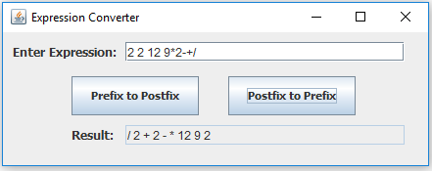

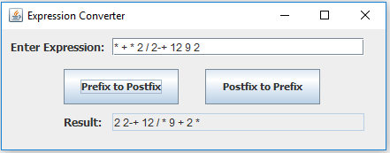

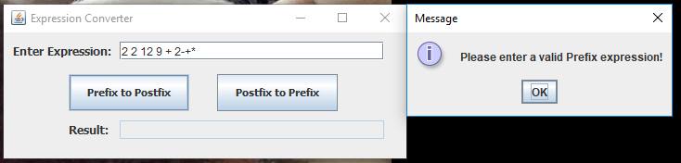

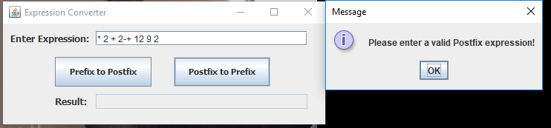

**Reflection:** For this project, I learned a few new concepts of programming. The first being the algorithm of converting prefix and postfix expressions. I have never heard of these before this project, and while I still do not feel that I have fully grasped how they work, it is very interesting. The other key concept that I learned was the StringTokenizer. I never used this class before, but this project allowed me to see how useful they are.